B/B Passage Strategy
- You need to understand signaling pathways i.e. what increases what, what inhibits what, etc…
  - I always need to draw out pathways for it to be easy to understand & sometimes lil drawings can help (I assure you they will not slow you down, I still have extra time doing this)
  - This helps me create a streamlined approach = faster at answering questions
- I usually read the entire passage because one sentence in the passage can lead to an answer (unless I 100% know I can answer the questions without the passage but this is a little more rare)
  - Yes there is a small chance you can run out of time if you dwell on certain passages though. If you run out of time easily, maybe don’t do this.
- Sometimes B/B passages require some background bio info as well, which is something that I just have intimate knowledge of as a bio major
- My cousin scored a 516 and he said that it is generally best to have a good understanding of what figures mean (esp if a question references it).
  - For example: “Protein X increases Y mRNA levels based on Figure 1”

Let me give an example to how I draw out pathways, here is a passage and here is my drawing 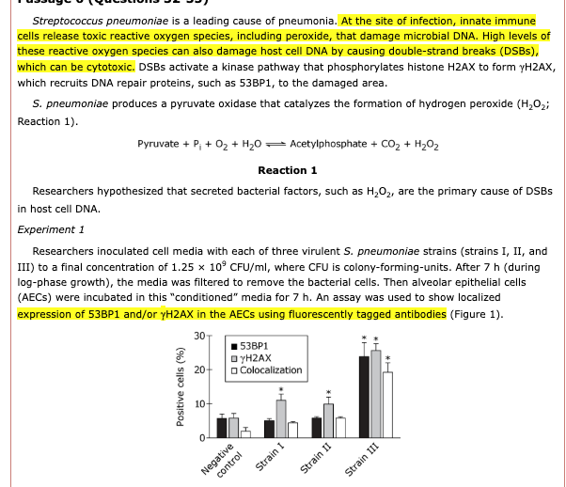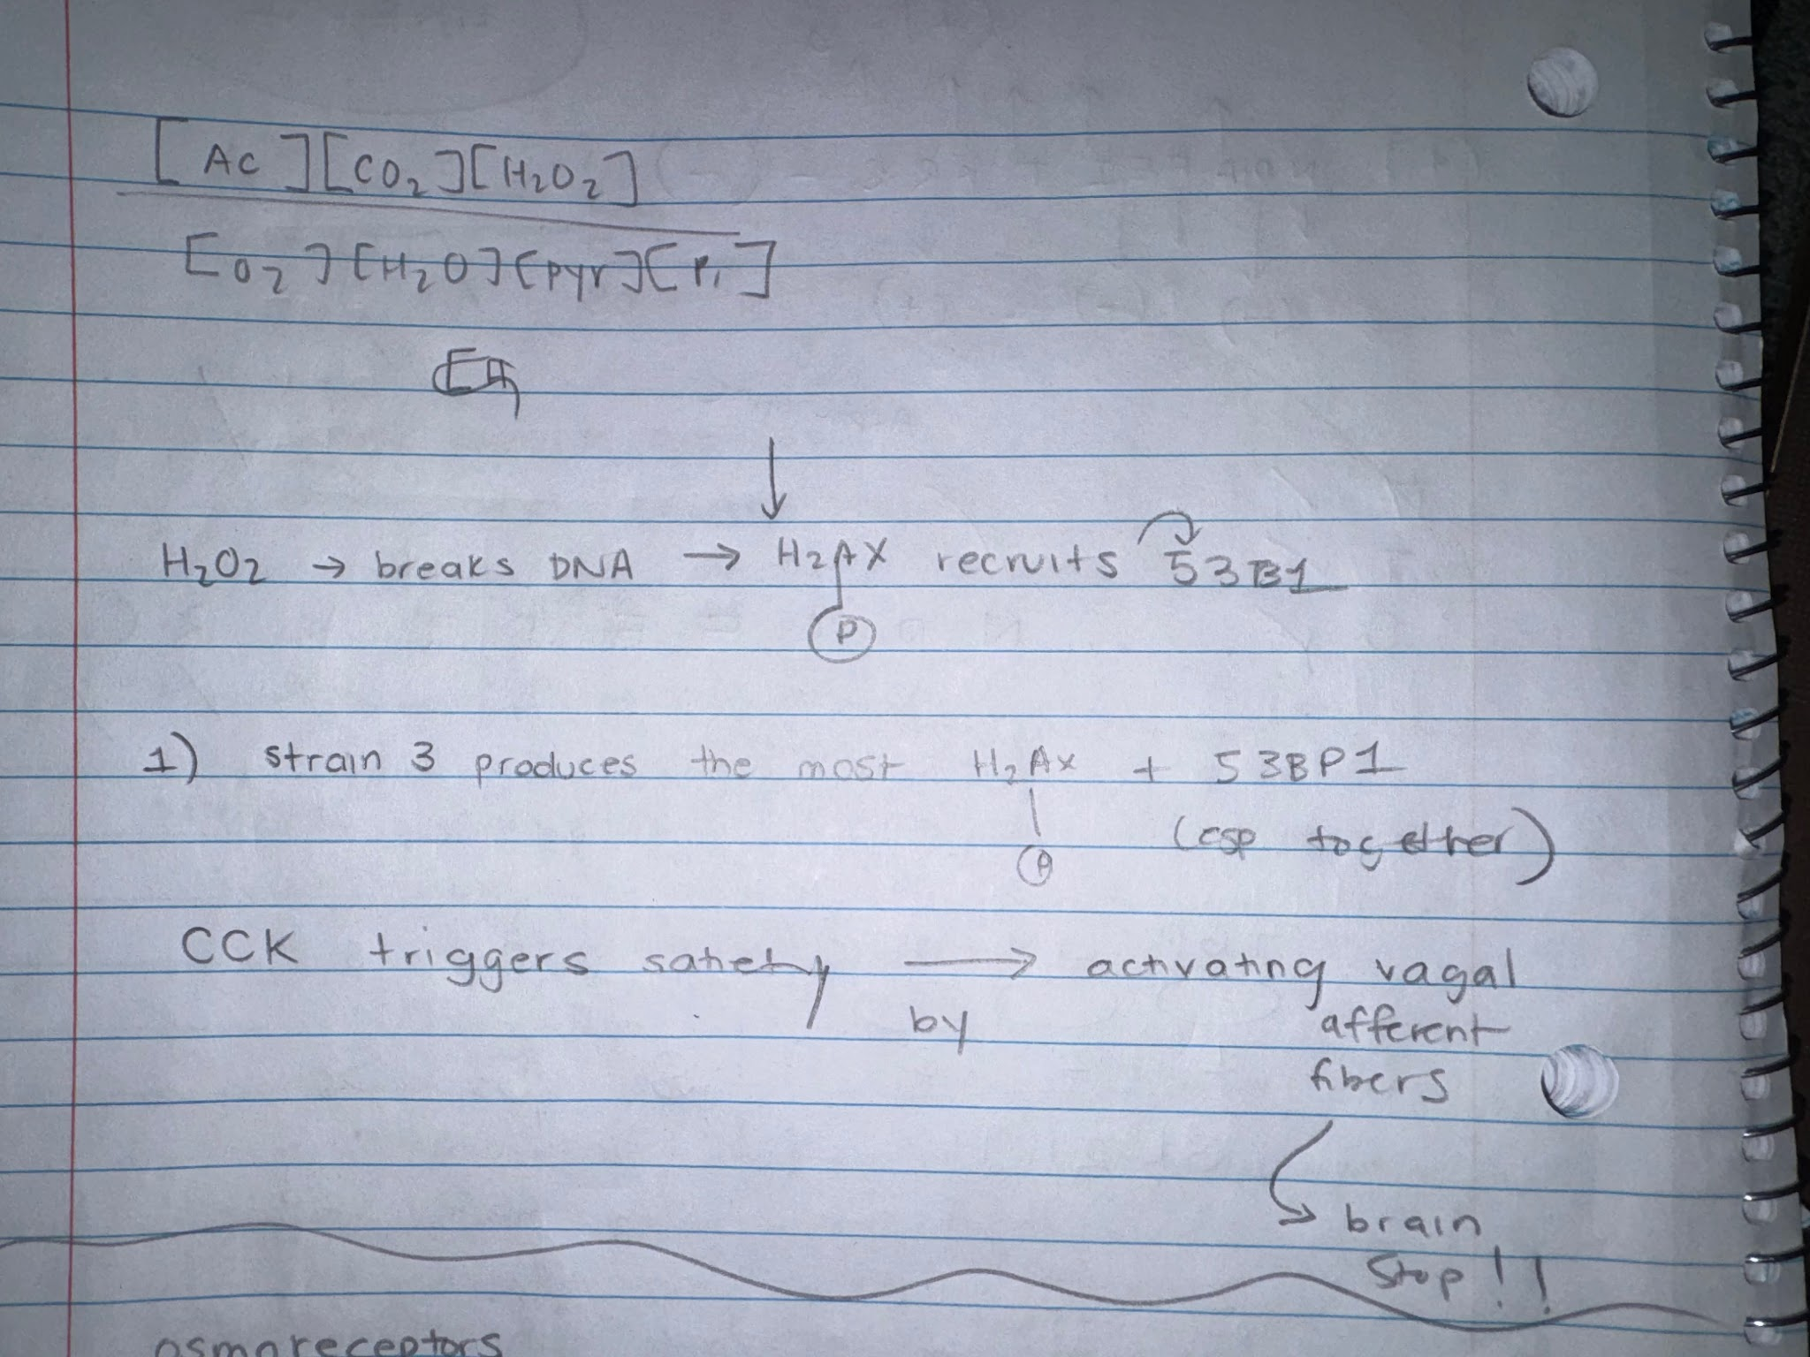
Even a simple flow chart like this allows me to get a streamlined idea of the steps of a signaling pathway.
See page 2 →

As a bio major I am extremely familiar with what vocab words like “transfection” and “knockout” mean. I became so used to reading papers like the B/B passages in undergrad, so I think it would be best to brush up on some vocab and common ways biology is tested, usually by removing genes or silencing them. ChatGPT is my go to resource LOL (I have premium).
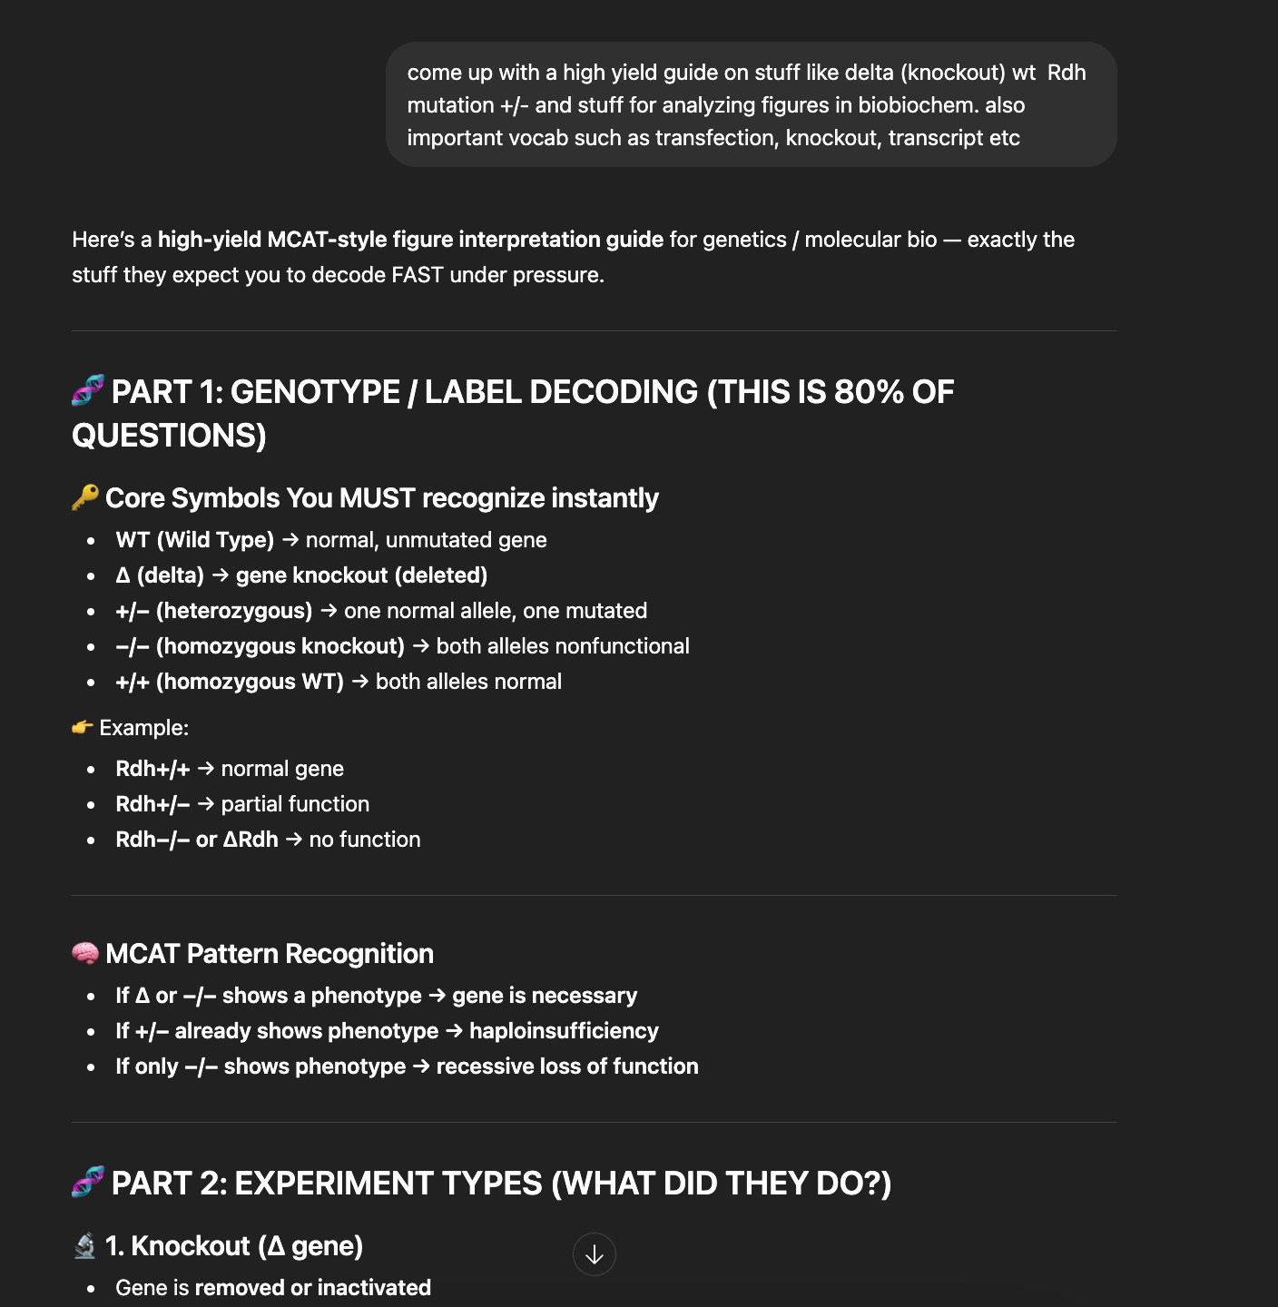

One thing you could do is take previous passages from UWorld + AAMC, draw out the
pathways, check if you interpret them correctly with the help of Google Notebook LM or ChatGPT.

B/B Content Review
- General Biology/Biochemistry: Professor Eman Updated MCAT Biology Updated MCAT Biochemistry
- GPCR: Science Simplified Signal Transduction Cascades MCAT Cellular Biology (GCPR, G Proteins, Adenyl Cyclase, PLC)
- Metabolism/Biochemistry: NinjaNerd www.youtube.com/@NinjaNerdOfficial
- Lab Techniques: Lab Techniques Link

I mostly used YouTube videos as content review and did UWorld alongside it. So let’s say I finished the Metabolism videos from NinjaNerd, then I would complete as many UWorld questions as possible. Know what topics are high yield and become familiar with them. I always review my FLs so I can prevent similar mistakes on the real thing. My FL B/B, P/S and C/P averages really improved once I completed AAMC question banks and section banks.

